Problem: Graph connectivity using dfs

#include<stdio.h>

int visit[100];

int a[100][100];

int n;

void dfs(int v)

{

int i;

visit[v]=1;

for (i=1;i<=n;i++)

{

if((a[v][i]==1) &&(visit[i]==0))

dfs(i);

}

}

int check(int v)

{

if(n==v)

return 1;

if(visit[v]==0)

return 0;

check(v+1);

}

void create_graph()

{

int i;int j;

while(1)

{

printf("Enter the source and the destination vertex of the edge\n");

scanf("%d %d",&i,&j);

if(i==0 && j==0) //to stop taking input

break;

a[i][j]=1; //for undirected graph: Its should be a[i][j]=a[j][i]=1;

}

}

int main()

{

int i;int v;int k;

printf("Enter the number of vertices\n");

scanf("%d",&n);

create_graph();

printf("Enter the source vertex\n");

scanf("%d",&v);

dfs(v);

int success=check(0);

if(success)

printf("%s\n","All nodes are reachable");

else

printf("%s\n","Nodes arnt reachable");

return 0;

}

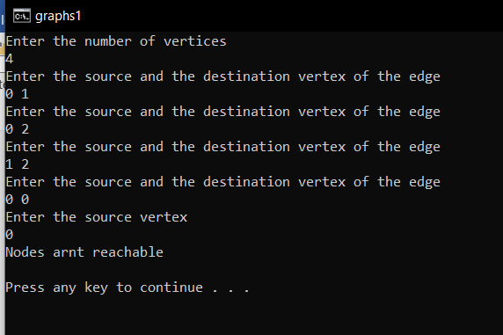

Problem: Graph transversal using bfs

// BFS algorithm in C

#include <stdio.h>

#include <stdlib.h>

#define SIZE 40

struct queue {

int items[SIZE];

int front;

int rear;

};

struct queue* createQueue();

void enqueue(struct queue* q, int);

int dequeue(struct queue* q);

void display(struct queue* q);

int isEmpty(struct queue* q);

void printQueue(struct queue* q);

struct node {

int vertex;

struct node* next;

};

struct node* createNode(int);

struct Graph {

int numVertices;

struct node** adjLists;

int* visited;

};

void bfs(struct Graph* graph, int startVertex) {

struct queue* q = createQueue();

graph->visited[startVertex] = 1;

enqueue(q, startVertex);

while (!isEmpty(q)) {

printQueue(q);

int currentVertex = dequeue(q);

printf("\nVisited %d\n", currentVertex);

struct node* temp = graph->adjLists[currentVertex];

while (temp) {

int adjVertex = temp->vertex;

if (graph->visited[adjVertex] == 0) {

graph->visited[adjVertex] = 1;

enqueue(q, adjVertex);

}

temp = temp->next;

}

}

}

struct node* createNode(int v) {

struct node* newNode = malloc(sizeof(struct node));

newNode->vertex = v;

newNode->next = NULL;

return newNode;

}

struct Graph* createGraph(int vertices) {

struct Graph* graph = malloc(sizeof(struct Graph));

graph->numVertices = vertices;

graph->adjLists = malloc(vertices * sizeof(struct node*));

graph->visited = malloc(vertices * sizeof(int));

int i;

for (i = 0; i < vertices; i++) {

graph->adjLists[i] = NULL;

graph->visited[i] = 0;

}

return graph;

}

void addEdge(struct Graph* graph, int src, int dest) {

struct node* newNode = createNode(dest);

newNode->next = graph->adjLists[src];

graph->adjLists[src] = newNode;

newNode = createNode(src);

newNode->next = graph->adjLists[dest];

graph->adjLists[dest] = newNode;

}

struct queue* createQueue() {

struct queue* q = malloc(sizeof(struct queue));

q->front = -1;

q->rear = -1;

return q;

}

int isEmpty(struct queue* q) {

if (q->rear == -1)

return 1;

else

return 0;

}

void enqueue(struct queue* q, int value) {

if (q->rear == SIZE - 1)

printf("\nQueue is Full!!");

else {

if (q->front == -1)

q->front = 0;

q->rear++;

q->items[q->rear] = value;

}

}

int dequeue(struct queue* q) {

int item;

if (isEmpty(q)) {

printf("Queue is empty");

item = -1;

} else {

item = q->items[q->front];

q->front++;

if (q->front > q->rear) {

printf("Resetting queue ");

q->front = q->rear = -1;

}

}

return item;

}

void printQueue(struct queue* q) {

int i = q->front;

if (isEmpty(q)) {

printf("Queue is empty");

} else {

printf("\nQueue contains \n");

for (i = q->front; i < q->rear + 1; i++) {

printf("%d ", q->items[i]);

}

}

}

int main() {

int n;

printf("Enter the size of graph:");

scanf("%d",&n);

struct Graph* graph = createGraph(n);

int p,q;

while(1)

{

printf("Enter source and destination:");

scanf("%d %d",&p,&q);

if(p<0 || p>n || q<0 || q>n)

break;

addEdge(graph,p,q);

}

bfs(graph, 0);

return 0;

}

